Air Pollution & Health Impact Correlation in India (2023–2024)

1. Introduction
This report explores the multifaceted impact of air pollution on public health, consumer behavior, and urban air quality trends in India for the period 2023–2024. It addresses five key questions: age-specific vulnerability, air purifier market dynamics, city population vs AQI correlation, public AQI awareness, and effectiveness of government policies.

2. Age-Wise Health Impacts
National-level studies show that newborns face approximately 86% higher mortality risk, while children under five experience 100–120% increased health risk due to air pollution. Adults face around 13% higher mortality when PM2.5 levels exceed standards. Cities like Delhi and Lucknow have reported rising lung-related illnesses even among non-smokers, women, and youth. (Sources: Economic Times, The Guardian, PMC)

3. Indian Air Purifier Market Landscape
The Indian air purifier market is led by brands such as Daikin, Dyson, Philips, Honeywell, Kent, Sharp, Xiaomi, and Eureka Forbes. The market was valued at approximately USD 507.5 million in 2024, with a projected CAGR of ~14% till 2033. Differentiators include:
Price: Xiaomi and Kent in the mid-range; Dyson and Daikin in the premium segment.
Filtration: All major brands offer HEPA + Activated Carbon; premium ones add UV ionizers ,and smart features.
Smart Features: App-based control, real-time AQI monitoring, and voice assistants.
(Source: GMIR, IMARC Group)

4. City Population Size vs Air Quality (AQI)
Larger cities do not always experience worse air quality. While metros like Delhi are highly polluted, several smaller cities such as Byrnihat (Assam) have higher AQI levels. Cities in Kerala, Goa, and western Maharashtra maintain better AQI despite dense populations. This indicates that geography, local industry, and regulation are also crucial.

5. Awareness of AQI and Health Implications
Survey studies indicate that while citizens in polluted metros are aware of poor air quality, there is limited understanding of the AQI scale and its health consequences. Public health experts recommend that AQI communication should be linked more clearly to health risk levels. (Source: Bengaluru Sustainability Forum, PMC, Health Policy Watch)

6. Pollution Control Policies: Effectiveness Across Cities
The National Clean Air Programme (NCAP), launched in 2019, aimed for 20–30% reduction in PM2.5/PM10 levels by 2024 (later updated to 40% by 2026). Between 2019–2023, 27 of 49 tracked cities reported improvement. Mumbai and Kolkata saw notable PM10 reductions (~44% and 37% respectively), while Delhi and Faridabad lagged. Other initiatives like BSVI norms, EV promotion, and LPG access had mixed results. (Source: Times of India, Health Policy Watch)

7. Summary & Recommendations
- Most vulnerable: Children under five, elderly, and those with respiratory illnesses.
- Consumer behavior: Market is expanding; smart features and filtration differentiate brands.
- AQI vs Population: Larger cities aren't always more polluted — geography and policies matter.
- Awareness: Needs strengthening with direct health messaging.
- Policies: NCAP has had localized successes, but better enforcement is needed.
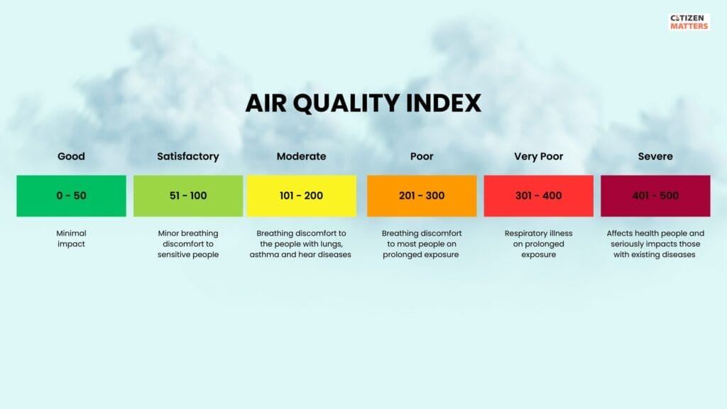

8. References
- Economic Times: https://m.economictimes.com
- PMC: https://pmc.ncbi.nlm.nih.gov
- The Guardian: https://www.theguardian.com
- IMARC Group: https://www.imarcgroup.com
- GMIR: https://www.gmiresearch.com
- IQAir: https://www.iqair.com
- Reddit India: https://www.reddit.com/r/AskIndia
- Times of India: https://timesofindia.indiatimes.com
- Health Policy Watch: https://healthpolicy-watch.news
- Bengaluru Sustainability Forum: https://www.bengalurusustainabilityforum.org

